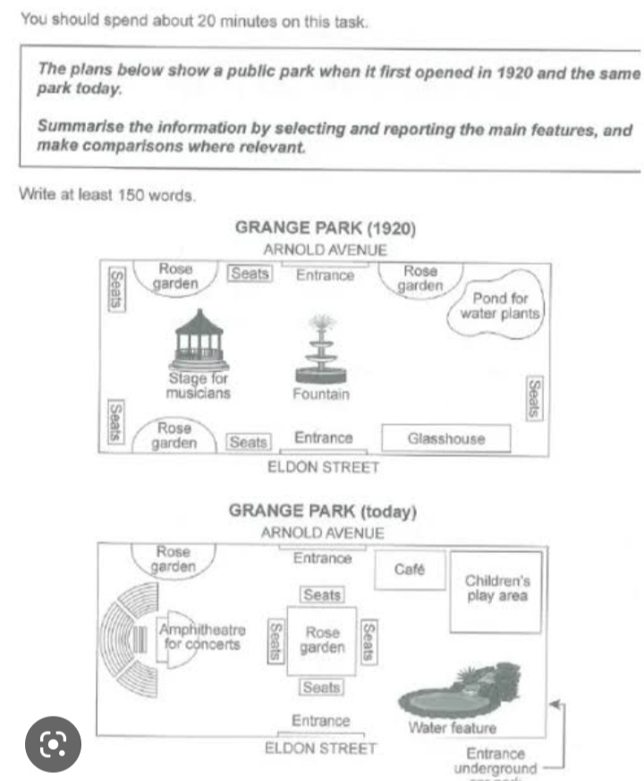
The provided arrangement illustrates a city garden when it initially inaugurated in 1920 and the same park today.
Overall, all the amenities of the garden evolved by the time and new infrastructure take place to the previous one.
Looking back to the details, the picture depicted the development of park from 1920 to present days. In the first time frame there are two entrances which are located in the north and south side, while there is new hidden way to enter the garden which is located in the south west side called underground entrance. Moreover, there were a Fountain in the center of the green space which is replaced with the Rose Garden, surrounded with seats to view the lash green grass to fresh public minds. Furthermore, there is another prominent place, Stage for musicians which is developed and converted into a grand Amphitheatre for concerts which have a spectacular sitting area to victim the sight, which is shaped like a stadium. In addition, Water feature now took the place of Pond for water plants. Finally, a drastic changing which leads the tourist attention is Children’s play area, parents are satisfied with this changing.
ST: 8:33 ET: 53

